**Kanal Fest**

**22/08/2023**

The National Service Scheme and Women's Cell of Government College Ambalapuzha, in collaboration with the Women and Child Development Department of Alappuzha, organized an awareness program on gender equality on August 22, 2023. The main highlights of the event included a self-defence training program and a debate on the topic of "benevolent sexism."

During the inaugural session, Smt. Sijoy Thomas, the District Mission Coordinator, delivered the welcoming address. The session was presided over by Dr. Mothi George, the Principal of Govt. College Ambalapuzha. Smt. Soumya R, the Alappuzha District Women Protection Officer, inaugurated the session. Following this, Sri. Shajim M S, the NSS Programme Officer, Smt. Sheena S, the Women's Cell Coordinator, and Smt. Russel Bind, the ICDS Supervisor, delivered felicitation speeches.

After the inaugural session, Smt. Sulekha Prasad, Assistant Sub Inspector of the Crime Branch in Alappuzha District, conducted a self-defence training program for the students of Ambalapuzha Government College. It proved to be an effective program, offering a fresh perspective, especially to the female students.

Following the training program, a debate on the topic of benevolent sexism was led by Dr. Unnikrishnan G, an Assistant Professor of Political Science, Govt. College Ambalapuzha. To conclude the session, Sri. Ananthapadmanabhan, an NSS Volunteer, delivered the Vote of Thanks.

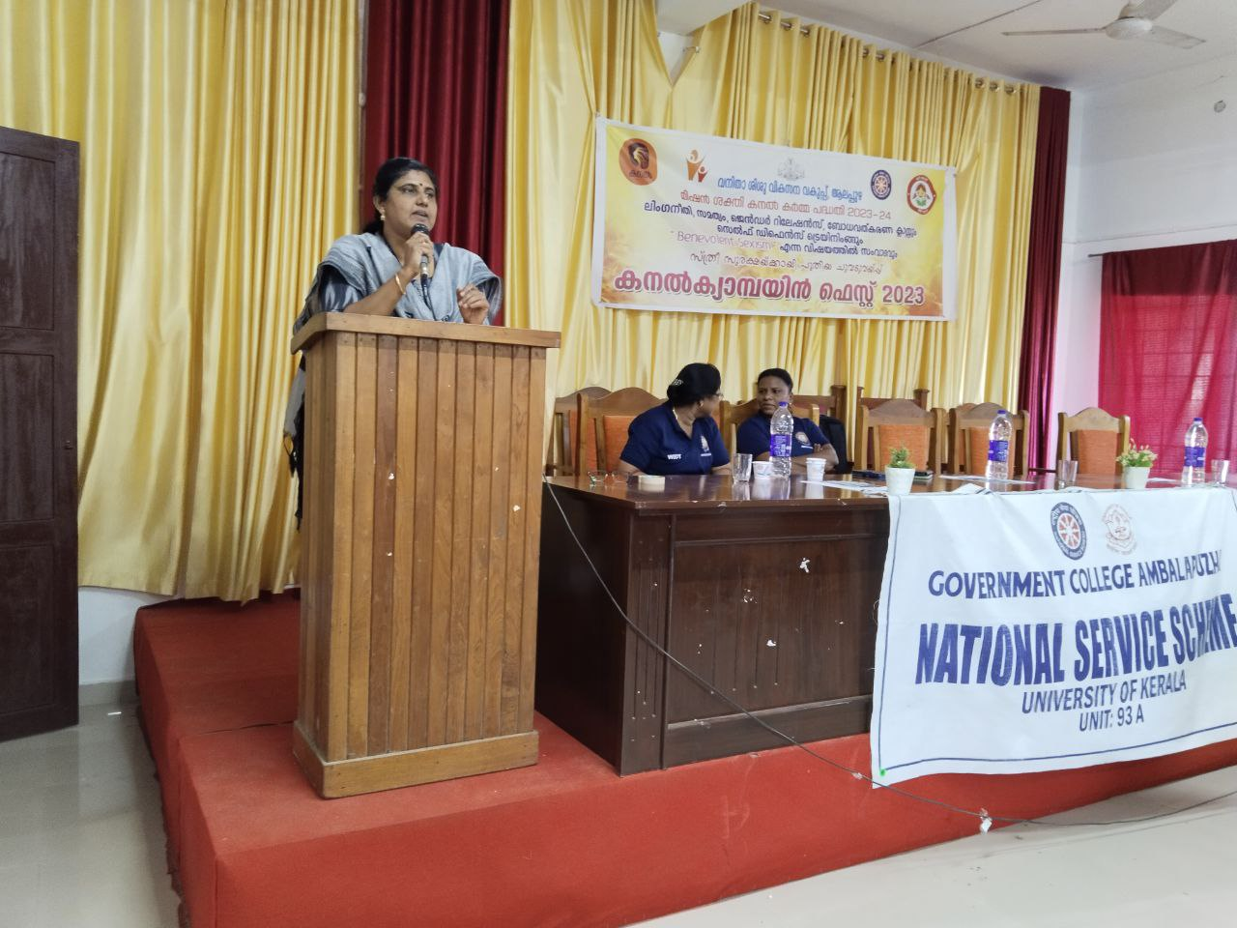

Inauguration: Smt. Soumya R, the Alappuzha District Women Protection Officer

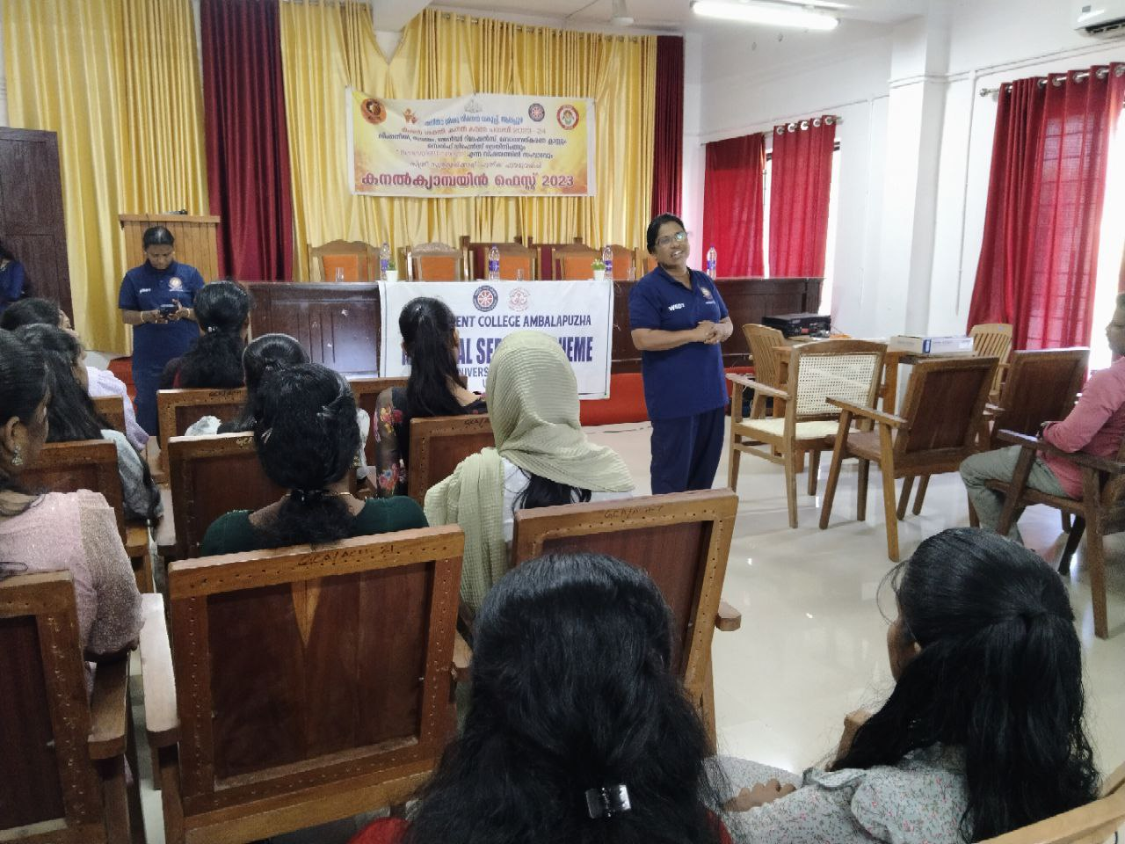

Self-Defence Training Programme

Smt. Sulekha Prasad, Assistant Sub Inspector of the Crime Branch in Alappuzha District

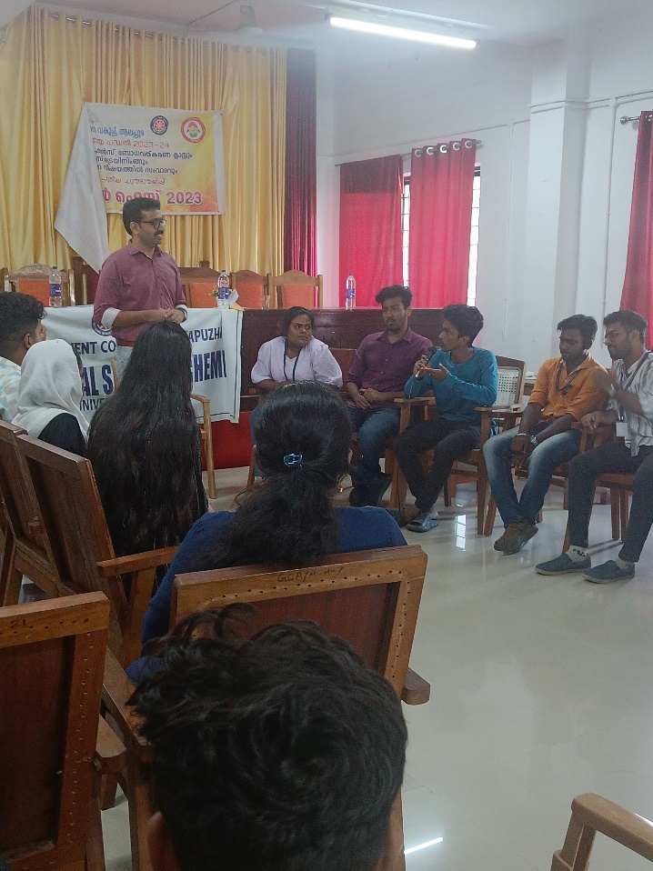

Debate on “Benevolent Sexism”

Lead by Dr. Unnikrishnan G, Assistant Professor of Political Science, Govt. College Amabalapuzha

